**Practical no 11**

**Implement Map reduces operation with a suitable example using MongoDB.**

use College

---------------------------------------

**create collections:-**

db.createCollection("Books")



---------------------------------------

**insert records:-**

db.Books.insert({Roll_no:1,Name:"Premraj",Book_name:"I too had alove story",Type:"Ebook",Status:"P",Price:100})

db.Books.insert({Roll_no:2,Name:"Nikita",Book_name:"Wings Of Fire",Type:"Online",Status:"P",Price:101})

db.Books.insert({Roll_no:1,Name:"Premraj",Book_name:"Java Black Book",Type:"Ebook",Status:"U",Price:103})

db.Books.insert({Roll_no:3,Name:"Rohan",Book_name:"DBMS",Type:"Online",Status:"P",Price:102})

db.Books.insert({Roll_no:4,Name:"Mahesh",Book_name:"RedHat",Type:"Online",Status:"U",Price:104})

db.Books.insert({Roll_no:4,Name:"Mahesh",Book_name:"Redhey",Type:"Ebook",Status:"P",Price:105})

---------------------------------------

db.Books.find()

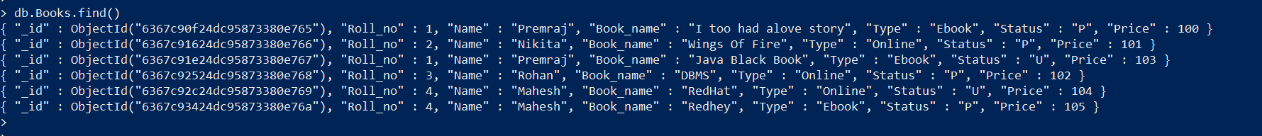

---------------------------------------

**mapreduce functions:-**

var mapFunction1=function(){emit(this.Roll_no,this.Price);}

var reduceFunction1=function(keyRoll_no,values_unpaid){return Array.sum(values_unpaid);}

db.Books.mapReduce(mapFunction1,reduceFunction1,{out:"Unpaid"})

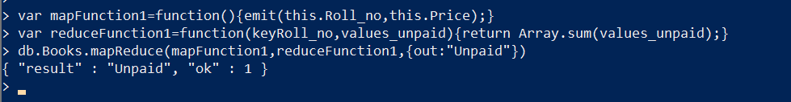

---------------------------------------

db.Unpaid.find()

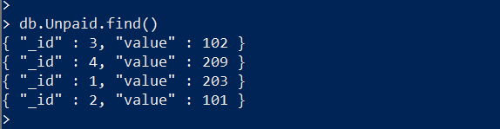----------------------------------

db.Books.mapReduce(function(){emit(this.Roll_no,this.Price);},

function(key,values) {return Array.sum(values)},

{query:{Type:"Ebook"},out:"Books_new"})

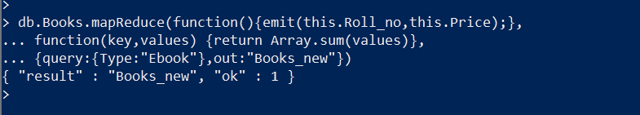

---------------------------------------

db.Books_new.find()

